Compte Rendu Complet de TP ERP
Ahmed Riadh Hedhili
L2CS02

TP1
Ex1:
- - An Information System (IS) is an organized set of people, data, procedures, and tools that allow information to be collected, processed, stored, and disseminated within an organization.
- A Computer System: This is the technical part of an information system and includes computers, software, databases, and companies.
2) A business process (processus métier) represents a series of organized activities aimed at producing added value and responding to a specific objective within the organization. Examples include sales, recruitment, and production processes.
3) Business processes define what an organization does, and information systems support and automate these processes, contributing to improved coordination between departments, faster business execution, and smoother operations.
4) Examples of ERP systems:
BAGE, odoo, Microsoft Dynamics, Oracle ERP, SAP, ERPNext

5) Examples of the most important ERP modules:
- Sales and Purchasing Management
- Inventory Management
- Accounting and Finance
- Human Resources
- Production
- Customer Relationship Management (CRM)
- Maintenance
- Marketing
6) Odoo Community: Free and open source, it supports basic functions but lacks official support and advanced applications.
Odoo Enterprise: Paid and closed source, it offers advanced functions, official support, and advanced applications.
7) Benefits of an ERP system for an organization:
1. Data standardization and integration
2. Improved productivity
3. Reduced errors
4. Support for decision-making
5. Process automation
6. Time and cost savings
7. Improved coordination between different departments

TP2
Ex1: (Modélisation d'un processus simple)
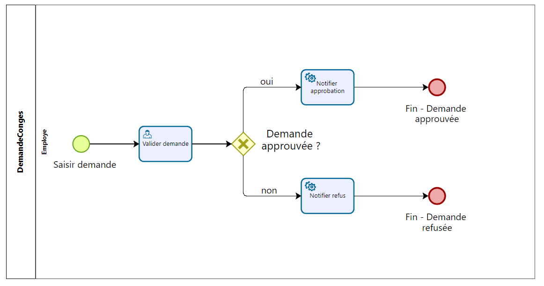
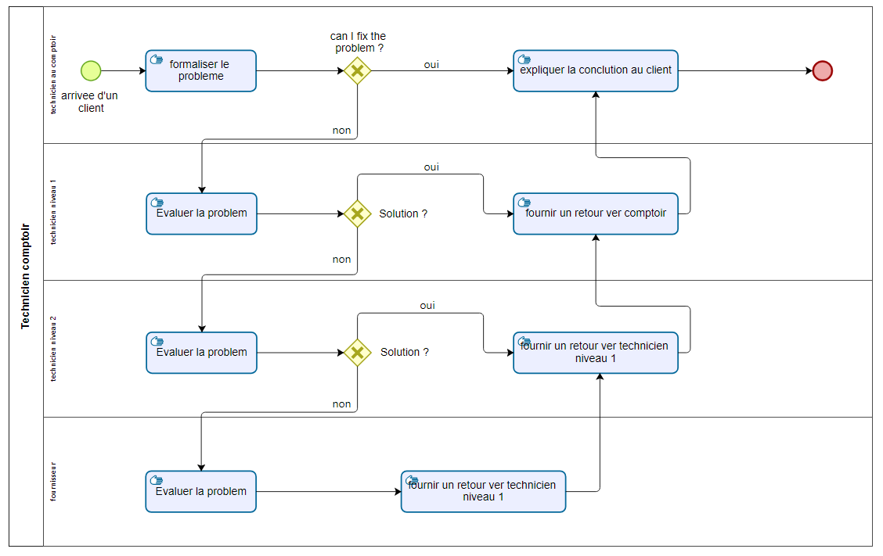
Ex2: (Modélisation d’un processus de gestion des incidents)

TP3
Game purchase website "GamingAA"


